

**Batch: B-1 Roll No.: 16010422234 Experiment No.: 6**

**Aim:** Simulation of Newspaper Seller Inventory System using spreadsheet **__________________________________________________________________________**

**Resources needed: Excel Spreadsheet**

**__________________________________________________________________________**

**Theory**

**Problem Statement:**

A classical inventory problem concerns the purchase and sale of newspapers. The newsstand buys the papers for 33 cents each and sells them for 50 cents each. Newspapers not sold at the end of the day are sold as scrap for 5 cents each. Newspapers can be purchased in bundles of 10. Thus, the newsstand can buy 50, 60, and so on. There are three types of

news days: "good"; "fair"; and "poor''; they have the probabilities 0.35, 0.45, and 0.20, respectively.

The distribution of newspapers demanded on each of these days is given ,in Table 1. The problem is to compute the optimal number of papers the newsstand should purchase. This will be accomplished by simulating demands for 20 days and recording profits from sales each day.

**Table 1: Distribution of Newspapers Demanded**

| **Distribution of Newspapers Demanded** | | | | | | |
| --- | --- | --- | --- | --- | --- | --- |
| **Demand** | **Demand Probabilities** | | | **Cumulative Probabilities** | | |
| **Good** | **Fair** | **Poor** | **Good** | **Fair** | **Poor** |
| 40 | 0.03 | 0.10 | 0.44 | 0.03 | 0.10 | 0.44 |
| 50 | 0.05 | 0.18 | 0.22 | 0.08 | 0.28 | 0.66 |
| 60 | 0.15 | 0.40 | 0.16 | 0.23 | 0.68 | 0.82 |
| 70 | 0.20 | 0.20 | 0.12 | 0.43 | 0.88 | 0.94 |
| 80 | 0.35 | 0.08 | 0.06 | 0.78 | 0.96 | 1.00 |
| 90 | 0.15 | 0.04 | 0.00 | 0.93 | 1.00 | 1.00 |
| 100 | 0.07 | 0.00 | 0.00 | 1.00 | 1.00 | 1.00 |

The profits are given by the following relationship:

Profit = ( revenue from sales ) - ( cost of newspapers) - (lost profit from excess demand) + (salvage from sale from scrap)

From the problem statement, the revenue from sales is 50 cents for each paper sold. The cost of newspapers is 33 cents for each paper purchased. The lost profit from excess demand is 17 cents for each paper demanded that could not be provided. Such a shortage cost is somewhat controversial, but makes the problem much more interesting. The salvage value of scrap papers is 5 cents each.

To solve this problem by simulation requires setting a policy of buying a certain number of papers each day, then simulating the demands for papers over the 20-day time period to determine the total profit.

The policy (number of newspapers purchased) is changed to other values and the simulation repeated until the best value is found.

**Use of Random Nos.:**

* For generating type of Newsday
* For generating Demand

**Performance measures:**

* **Total profit**

**__________________________________________________________________________**

**Procedure / Approach /Algorithm / Activity Diagram:**

**Simulate using simulation table**

Develop a simulation table considering the newspaper dealer purchases 70 papers for 20 days and compute the profit earned.

**__________________________________________________________________________**

**Results: (Program printout with output / Document printout as per the format)**

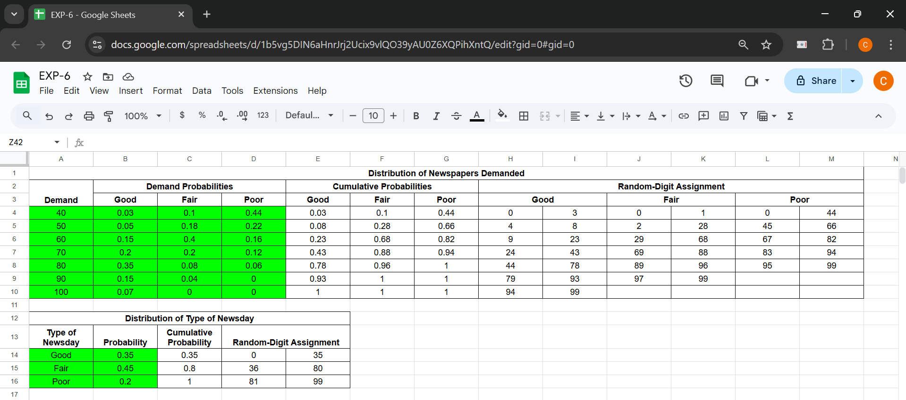

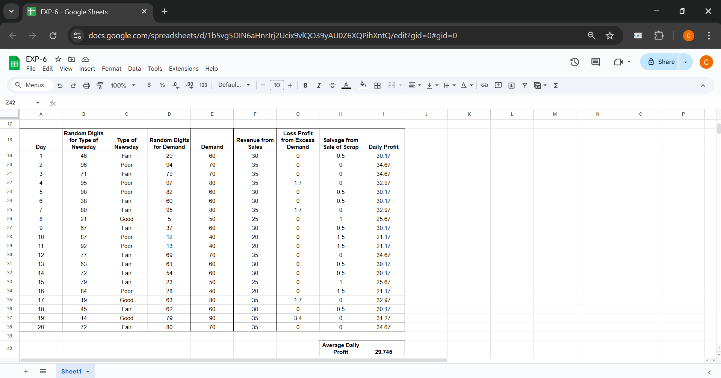

**__________________________________________________________________________**

**Questions:**

1. **Give real world examples which can be modelled as inventory systems?**

* Retail Inventory Management: Managing stock levels in stores to meet customer demand while minimizing overstock or understock situations.
* Warehouse Management: Optimizing stock levels in warehouses for timely delivery to retailers or customers.
* Grocery Stores: Managing stock of perishable goods with expiration dates, balancing inventory to prevent waste while ensuring products are available for customers.
* Manufacturing: Ensuring the right amount of raw materials and parts are available for production lines without excess storage costs.

1. **Name simulation language or package which can be used for modeling inventory systems?**

* Arena Simulation Software: Widely used in discrete event simulation modeling for inventory systems.
* Simul8: A simulation package that supports inventory management and supply chain models.
* AnyLogic: A multi-method simulation software that can model inventory systems using discrete-event, agent-based, and system dynamics models.
* MATLAB/Simulink: Provides tools for discrete event simulations and modeling inventory systems using custom-built models.

**__________________________________________________________________________**

**Outcomes: Apply the experimental process of a simulation using spreadsheets as well as**

**Simulation language/package.**

**_________________________________________________________________________**

**Conclusion: (Conclusion to be based on outcomes)**

The newspaper seller inventory system simulation was successfully conducted to determine the optimal number of newspapers a newsstand should purchase. After simulating demands over a 20-day period, various policies were tested, and profits were computed for each scenario. Through this simulation, we were able to evaluate the impact of purchasing decisions on profits, factoring in the costs of newspapers, lost profit from unfulfilled demand, and salvage from unsold newspapers. The simulation allowed us to observe how demand uncertainty, with different probabilities for "Good," "Fair," and "Poor" news days, affects the profitability of the business. The optimal purchase policy was determined based on the highest total profit generated from the simulation results.

**_______________________________________________________________________**

**Grade: AA / AB / BB / BC / CC / CD / DD**

**Signature of faculty in-charge with date**

**__________________________________________________________________________**

**References:**

**Books/ Journals/ Websites:**

**Text Book:**

1. Banks J., Carson J. S., Nelson B. L., and Nicol D. M., “Discrete Event System Simulation”, 3rd edition, Pearson Education, 2001.

**__________________________________________________________________________**